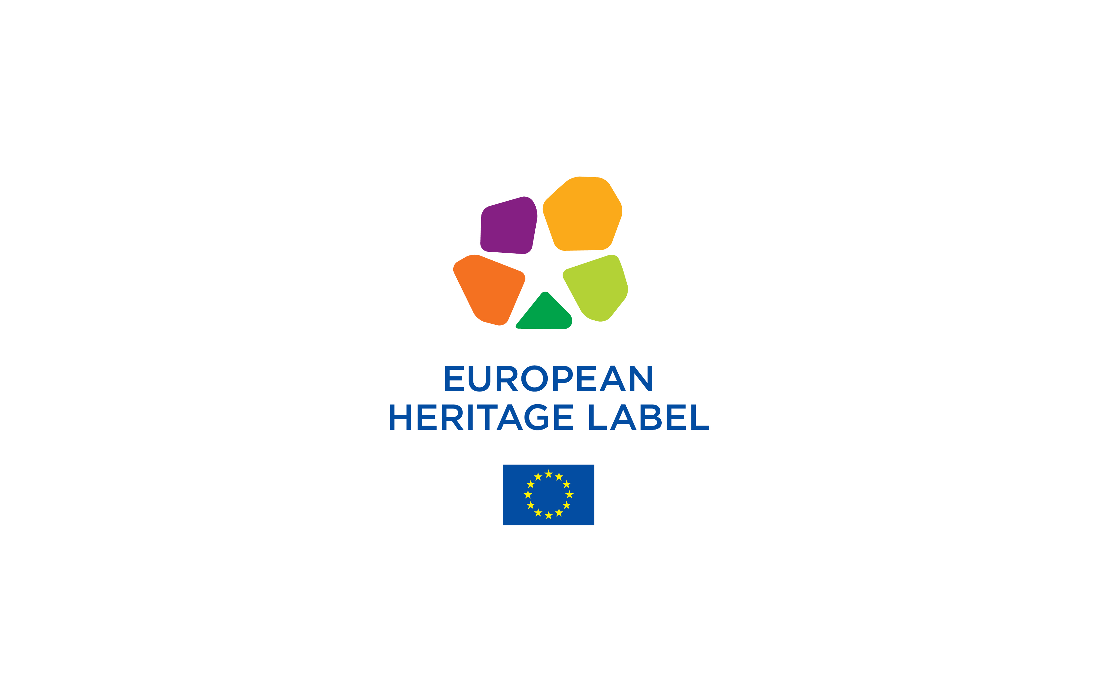

EUROPEAN HERITAGE LABEL
SELECTION 2025
TRANSNATIONAL APPLICATION FORM

Table of Contents

PARTⅠ- IDENTITY OF THE CANDIDATE TRANSNATIONAL SITE
1. GENERAL INFORMATION ON THE TRANSNATIONAL SITE
1.1. Description of the Transnational Site
1.2. Contact Details – Transnational Site
1.3. Summary of the Application – Transnational Site
1.4. Logo/ Institutional Visual of the Transnational Site
PART II - SPECIFIC INFORMATION ABOUT PARTNER-SITES
1. DESCRIPTION OF THE PARTNER-SITES
1.A. General information about the partner-site
1.B. Location and physical description of the partner-site
1.C. General historical description of the partner-site
2. AWARD CRITERIA
2.A. The symbolic European value of the partner-site
2.B. The project for the partner-site
2.C. Raising awareness of the European significance of the partner-site
2.D. Organising educational activities
2.E. Promoting multilingualism
2.F. Cooperating with other European Heritage Label sites
2.G. Promotion of the site by using new technologies
2.H. Raising the profile and attractiveness of the site on a European scale
2.I. Contemporary artistic and cultural activities
2.J. Project Implementation Plan: Listing planned activities
2.K. Operational capacity of the partner-site
2.L. Operational capacity of the partner-site – Work Plan
2.L.1. Management of the partner-site
2.L.2. Preservation of the partner-site
2.L.3. Reception facilities, visitor information and signposting in the partner-site
2.L.4. Public access of the partner-site
2.L.5. Special attention to young people in the partner-site
2.L.6. Sustainable tourism in partner-site
2.L.7. Communication strategy of the partner-site
2.L.8. Environmentally friendly management of the partner-site
2.L.9. Operating budget of the partner-site
2.L.10. Organisational structure of the partner-site
PART III - THE JOINT APPLICATION
1. DESCRIPTION OF THE TRANSNATIONAL SITE
1.1. Location and physical description of the Transnational site
1.2. Transnational site’s history and historical context
2. AWARD CRITERIA
2.A. The symbolic European value of the Transnational site
2.B. The project for the Transnational site
2.C. Raising awareness of the European significance of the Transnational site
2.D. Organising educational activities
2.E. Promoting multilingualism
2.F. Cooperating with other European Heritage Label sites
2.G. Promotion of the Transnational site by using new technologies
2.H. Raising the profile and attractiveness of the site on a European scale
2.I. Contemporary artistic and cultural activities
2.J. Project Implementation Plan: Listing of planned activities
2.K. Operational capacity of the Transnational site – Work Plan

PARTⅠ- IDENTITY OF THE CANDIDATE TRANSNATIONAL SITE

- General information on the Transnational site
1.1. DESCRIPTION OF THE TRANSNATIONAL SITE
Name of the site
Countries the site exists in
Added value of the joint application (max. 150 words)

1.2. Contact Details – Transnational Site

The Coordinator organisation
Full name of the organisation
Street and number
Post code
Country
City or Region
Website
Social Media links
Name of the EHL project coordinator (contact person)
Telephone
E-mail

List of all other participating partner-sites
Name of the partner-site 1
Street and number
City or Region
Post code
Country
Website
Name of the EHL projectcoordinator (contact person)
Name of the partner-site 2
Street and number
City or Region
Post code
Country
Website
Name of the EHL project coordinator (contact person)

1.3. Summary of the Application - Transnational Site

Description of the site (max. 150 words)
European significance of the site (max. 150 words)
.
Project description (max. 150 words)
Operational capacity of the site (max. 150 words)

1.4. Logo/ Institutional Picture of the Transnational site

(For use by the Commission)

PART II - SPECIFIC INFORMATION ABOUT PARTNER-SITES

1. DESCRIPTION OF THE PARTNER-SITE
1.A. General information about the partner-site
Name of the site
Street and number
Post code
City or region
Country
Website
Social media links
Legal owner of the site
Managing authority(ies)
Name of the site manager
Name of the EHL project coordinator
Telephone
E-mail

1.B. Location and physical description of the partner-site
Provide at least one illustrative material (photos and/or maps) with a caption (max. 200 words)
1.C. General historical description of the partner-site

Please provide a short overview of the partner-site’s historical and cultural significance and the partner-site’s relation to European history and integration. (max. 200 words)

2. AWARD CRITEIA

2.A. The symbolic European value of the partner-site

(max. 200 words)

In this section candidate sites are asked to demonstrate that their site displays:
- a symbolic European value and/or
- a significant role in the history and culture of Europe and/or
- the building of the European Union

Please expand on at least one of the following criteria:
- The cross-border or pan-European nature of the site
- The place and role of the site in European history and culture and European integration Its links with key European events, personalities or movements
- The place and role of the site in the development and promotion of the common values that underpin European integration

For further guidance on the award criteria see the Guidelines for Candidate Sites (Section 5).

2.B The project for the partner-site (max. 200 words)

In this section, candidate partner-sites must elaborate on the project that they will carry out as part of the Transnational application. The proposed project must include all the elements listed in the following sections. Describe the project each of the partner-sites plan to implement for each element listed below. Describe the present situation within the partner-site and then outline the actions you intend to implement. Mention the Project Implementation Plan of each partner-site, listing all additional activities planned to be carried out by the candidate partner-sites. Please follow the Project Implementation guidelines carefully.
2.C. Raising awareness of the European significance of the partner-site (max. 200 words)
Describe how you intend to use available resources to raise awareness of the European significance of the candidate partner-site.
2.D. Organising educational activities (max. 200 words)
Describe the educational activities intended to be implemented by the candidate partner-site targeting young people. Under the Creative Europe these activities should aim to increase understanding of the common history of Europe, its shared yet diverse heritage and strengthen the sense of belonging to a common space.

Describe the present situation within the candidate partner-site and then outline the actions you intend to implement at a site level.

2.E. Promoting multilingualism (max. 200 words)
Describe how you intend to promote multilingualism.

Describe the present situation of the candidate partner-site, then outline the actions you intend to implement to encourage multilingualism, inclusion, equality, diversity, and participation. In the Project Implementation Plan, please list each activity to be carried out at a site level.

2.F. Cooperating with other European Heritage Label sites
(max. 200 words)
Describe how the candidate partner-site intends to exchange experiences with other EHL sites and initiate cooperative projects.

Specify the expectations from networking opportunities provided by the Label. Then outline how the site intends to contribute to exchange of experiences and/or to initiate cooperative projects with other EHL sites. Mention the role of specific partner-sites where relevant.

2.G. Promotion of the site by using new technologies (max. 200 words)
Describe how you intend to use new technologies to promote the partner-site on a European level.
Describe the present situation, then outline the actions you intend to implement and the tools that you intend to use.
2.H. Raising the profile and attractiveness of the site on a European scale (max. 200 words)
Describe the general approach to raising the European profile and attractiveness of the candidate partner-site by seeking synergies with other European initiatives.

Specify whether you currently take part in any other European initiatives (i.e. European Capitals of Culture, European Heritage Awards/Europa Nostra Awards, European Heritage Days, European Heritage Stories, European Cultural Routes, etc.) or other international programmes.

2.I. Contemporary artistic and cultural activities
(max. 200 words, optional to answer)

Describe the approach in the area of artistic and cultural activities - including the organisation of artistic and cultural activities that foster mobility of European cultural professionals, artists and collections, stimulate intercultural dialogue and encourage linkage between heritage and contemporary creation and creativity.

2.J. Project Implementation Plan: Listing planned activities
Project Activity | Details of actions  Specify here the action to be implemented | Intended outcome  Specify what the action intends to achieve and for whom (the final impact, the added value for the target group) | Timeline  How often will the activity be held? What is the duration of the activity? | Monitoring  How will the success of the implemented action be assesed?
Activity 1: Raising awareness of the European significance | Action
 | Action
 | Action
Activity 2: Organising educational activities | Action
 | Action
 | Action
Activity 3: Promoting multilingual access | Action
 | Action
 | Action
Activity 4: Taking part in networking activities | Action
 | Action
 | Action
Activity 5: Raising the profile and attractiveness | Action
 | Action
 | Action
Activity 6: Artistic and cultural activities (optional) | Action
 | Action
 | Action

2.K. Operational capacity of the partner-site

(max 200 words)
Provide a statement of the organisational structure of the partnership and the human resources allocated for the implementation of the partner-site project and the coordination of activities to be carried out solely by the site.

2.L. Operational capacity of the partner-site – Work Plan
To demonstrate their operational capacity, partner-sites also need to provide:
- A one-page operating budget statement for the overall management of the site (See 2.L.9.)
- A one-page statement on the organisational structure and human resources allocated to the implementation of the project. (See 2.L.10.)
2.L.1. Management of the partner-site (max 300 words)
Outline the overall management plan for the site and specify if further developments are planned.

2.L.2. Preservation of the partner-site (max. 250 words)
Outline the current protection regime for the site, including all relevant legal, regulatory, planning or institutional regulations regarding the site. Then describe the current state of preservation and specify any foreseen change or development.

.

2.L.3. Reception facilities, visitor information and signposting in the partner-site (max. 250 words)

Describe the partner-site’s current reception facilities, such as the historical presentation, visitor information and signposting. Make sure to mention whether the site is open to the public and its opening hours. Specify any foreseen changes or development.

2.L.4. Public access of the partner-site (max. 250 words)
Describe the partner-site’s access policy, focusing on the facilities and resources you have in place to ensure access to the widest possible public, including access for visitors with disabilities (offline and online), notably through site adaptations and/or staff training;
Specify any foreseen changes and/or development to improve access to the site and to visitor information for the widest public possible.

2.L.5. Special attention to young people in the partner-site
(max 250 words)
Describe what policy and resources this partner-site has in place to grant privileged access to young people. Specify any foreseen changes and/or development in the next four years.

2.L.6. Sustainable tourism in the partner-site (max 250 words)
Describe the partner-site’s policy and actions for promoting the site as a sustainable tourism destination.
Following the Creative Europe cross cutting priority, mention actions underaken by the partner- sites to encourge sustainable tourism including (but not limited to) activities related to:
- preserving natural and cultural resources
- limiting negative impacts of tourism, like the use of natural resources and waste production,
- promoting the wellbeing of the local communities and strengthening their involvement in decision-making processes with other stakeholders
- reducing the seasonality of demand
- limiting the environmental impact of tourism-related transport
- making tourism accessible to all
- improving the quality of tourism jobs
Please also mention if the partner-site is associated to any other initiatives at a broader local or regional level focusing on: 1) regenerating cities and regions through cultural heritage, 2) promoting adaptive re-use of heritage buildings and/or 3) balancing access to cultural heritage with sustainable cultural tourism and natural heritage.
Specify any foreseen changes and/or development in this area.

2.L.7. Communication strategy of the partner-site
Outline the current communication strategy for the partner-site. Present how you plan to develop a coherent and comprehensive communication strategy highlighting its European significiance to a wide audience and diverse target groups. Please include a broad outline of the communication activities you intend to undertake. (max. 250 words)

2.L.8. Environmentally friendly management of the partner-site
(max. 250 words)
Outline the partner-site’s environmental policy and/or measures taken to ensure that the management of the site is as environmentally friendly as possible.
Examples you may want to mention include (but are not limited to) whether you have developed sustainability standards for the day-to-day management of the partner-site and/or have taken steps towards:
- reducing the carbon footprint and environmental impact of the site
- minimising the use of energy and water
- minimising waste and encouraging reuse and recycling
- examining alternative renewable energy sources
- promoting the use of greener mode of transport for staff and/or visitors to reduce the environmental impact of associated travels
- integrating environmental criteria for procurement of goods and services
- integrating environmental and energy performance considerations in the design, refurbishment, and use of buildings
- ensuring local management of the site and locally provided goods and services

Specify any foreseen changes and/or development in this area.

2.L.9. Operating budget of the partner-site (max. 1 page)
Outline the current operating budget for the overall management of the partner-site (conservation works excluded). Include: annual running costs, communication costs, cultural, educational, research, networking activities costs. Identify also the principal sources of income available to the site.

2.L.10. Organisational structure of the partner-site (max. 200 words)
Provide a statement on the organisational structure and the human resources allocated to the implementation of the project in the partner-site.

PART III - THE JOINT APPLICATION

1. DESCRIPTION OF THE TRANSNATIONAL SITE
  - Location and physical description of the Transnational site
(max. 300 words)
Provide the locations of the selected partner-sites and add a general description of the Transnational site. Insert at least one piece of illustrative material (photos and/or maps) with a caption.
1.2. Transnational site’s history and historical context (max. 250 words)
Provide a general description of the history of the Transnational site as a whole. Explain how the partner-sites relate to each other and, if relevant, why this particular group of partner-sites has been selected to form the application.

2. AWARD CRITERIA

2.A. The symbolic European value of the Transnational site (max 400 words)

In this section candidate sites are asked to demonstrate that their site displays:
- a symbolic European value and/or
- a significant role in the history and culture of Europe and/or
- the building of the European Union.

Please expand on at least one of the following criteria:
- The cross-border or pan-European nature of the site
- The place and role of the site in European history and European integration. Its links with key European events, personalities or movements
- The place and role of the site in the development and promotion of the common values that underpin European integration

For further guidance on the award criteria see the Guidelines for Candidate Sites (Section 5).

2.B. The project for the Transnational site
To be attributed the label candidate sites must submit a project, which highlights their European symbolic value and European significance, described in the following sections.
The proposed project must include all the elements listed in the following sections.
This section of the application form asks you to describe your project for the site, its objectives, and the activities to be implemented for each element listed below.
2.C. Raising awareness of the European significance of the Transnational site(max. 250 words)

Describe how you intend to use available resources to raise awareness of the European significance of the Transnational site.

2.D. Organising educational activities (max. 250 words)
Describe the educational activities you intend to implement targeting young people and students. Under the Creative Europe these activities should aim to increase understanding of the common history of Europe, its shared yet diverse heritage and strengthen the sense of belonging to a common space.
Describe the present situation within the Transational site and then outline the actions you intend to implement.

2.E. Promoting multilingualism (max. 250 words)
Describe how you intend to promote multilingualism.
Describe the present situation of the Transnational site, then outline the actions you intend to implement to encourage multilingualism, inclusion, equality, diversity and participation. In the Project Implementation Plan, please list each activity to be carried out.

2.F. Cooperating with other European Heritage Label sites
(max 250 words)
Describe how you intend to exchange experiences with other EHL sites and initiate cooperative projects.

Specify the Transational site’s expectations from networking opportunities provided by the Label. Then outline how you intend to contribute to exchange of experiences and/or to initiate cooperative projects with other EHL sites. Mention the role of specific partner-sites where relevant.

2.G. Promotion of the Transnational site by using new technologies (max. 250 words)
Describe how you intend to use new technologies to promote the site on a European level.
Describe the present situation, then outline the actions you intend to implement and the tools that you intend to use.
2.H. Raising the profile and attractiveness of the site on a European scale. (max. 250 words)
Describe the general approach followed to raising the European profile and attractiveness of the Transnational site by seeking synergies with other European initiatives.
Specify whether you currently take part in any other European initiatives (i.e. European Capitals of Culture, European Heritage Awards/Europa Nostra Awards, European Heritage Days, European Heritage Stories, European Cultural Routes, etc.) or other international programmes.

2.I. Contemporary artistic and cultural activities (max. 250 words, optional to answer)

Describe the followed approach in the area of artistic and cultural activities - including the organisation of artistic and cultural activities that foster mobility of European culture professionals, artists, and collections, stimulate intercultural dialogue, and encourage linkage between heritage and contemporary creation and creativity. (max. 250 words, optional to answer)

2.J. Project Implementation Plan: Listing of planned activities
Project Activity | Details of actions  Specify here the action to be implemented | Intended outcome  Specify what the action intends to achieve and for whom (the final impact, the added value for the target group) | Timeline  How often will the activity be held? What is the duration of the activity? | Monitoring  How will the success of an implemented action be assessed?
Activity 1: Raising awareness of the European significance | Action
 | Action
 | Action
Activity 2: Organising educational activities | Action
 | Action
 | Action
Activity 3: Promoting multilingual access | Action
 | Action
 | Action
Activity 4: Taking part in networking activities | Action
 | Action
 | Action
Activity 5: Raising the profile and attractiveness | Action
 | Action
 | Action
Activity 6: Artistic and cultural activities (optional) | Action
 | Action
 | Action

2.K. Operational capacity of the Transnational site – Work Plan (max.250 words)
Provide a statement of the organisational structure of the partnership and the human resources allocated for the implementation of the Transnational site project and the coordination of activities to be carried out by all sites.

Applicants are required to duplicate table for each partner-site
Applicants are required to duplicate table for each partner-site

